 | 26.9.10 Editors - Geometry Nodes Editor - Header - Add Modifier Menu - Hair - Write modifiers
Table of content
Detailed table of content 1
Hair - Write modifiers 2
General functionality 2
Set Hair Curve Profile 3

Detailed table of content
Detailed table of content
Detailed table of content 1
Hair - Write modifiers 2
General functionality 2
Output Attributes 2
Internal Dependencies 2
Bake 2
Named Attributes 3
Set Hair Curve Profile 3
Replace Radius 3
Radius 3
Shape 3
Factor Min 3
Factor Max 3

Hair - Write modifiers

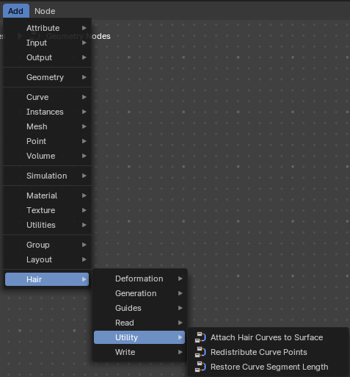
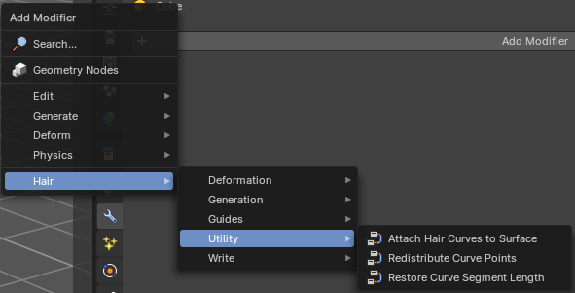
Hair nodes are Geometry node groups found in the Essentials Library included with Bforartists. They differ from the other nodes in the add menu due to being mid level node groups instead of individual low level nodes.
These hair nodes are also available as Modifiers. And this modifier adds the same node group as you would do it in the geometry node editor. Which means you can control these node groups in the modifier stack now instead of the geometry node editor.
Note that hair curves is usually a mesh only functionality. But shows for all other object types too.


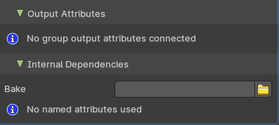
General functionality
All Hair nodes have an Output Attributes and Internal dependencies tab. If the hair node has output attributes or internal dependencies depends of the hair node.

Output Attributes
Contains group output attributes in case the node group has any. It is usually the output of the nodes besides the geometry.

Internal Dependencies

Bake
Define a bake name and a bake folder.
TODO: find out how this is meant to work.

Named Attributes
Named attributes of the hair node group in case the group has any.

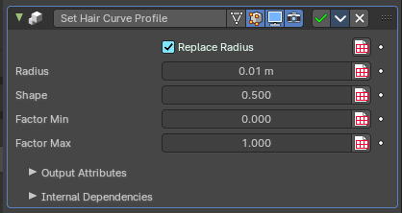
Set Hair Curve Profile
Set the radius attribute of hair curces according to a profile shape.

Replace Radius
Replace the original radius.

Radius
Base radius to be set when replace radius is enabled.

Shape
Shape of the radius along the curve.

Factor Min
Factor of the radius at the minimum.

Factor Max
Factor of the radius at the maximum.

